23CSE202 DATABASE MANAGEMENT SYSTEMS
S3 B.Tech CSE
Department of Computer Science and Engineering
Amrita School of Computing, Amritapuri Campus

3. Database Design Document

Group No : B7
Team Members :
Roll No | Student Name
AM.SC.U4CSE25114 | Devika B
AM.SC.U4CSE25115 | Dhanya Krishna
AM.SC.U4CSE25130 | Lakshmi V S

Project Title : FoodExpress - Online Food Delivery UI

3.1. Detailed description of the project
FoodExpress is a multi-vendor online food delivery platform where customers can discover nearby restaurants, build a cart containing dishes from several kitchens, and at checkout choose either to keep the items as separate orders (each with a normal delivery fee) or merge them into one combined delivery that carries twice the normal fee. Every restaurant can be linked to multiple cuisines so it appears under several category filters, while customers register with basic credentials, store multiple addresses, browse menus that show dish name, description, price, category and vegetarian status, and place orders that capture exact unit prices and quantities at the moment of purchase.
Once placed, a restaurant partner updates the order status from confirmed through preparing and ready, after which a delivery partner collects the food and progresses it to out-for-delivery and delivered; for merged orders an overall status is derived from the individual sub-orders. Payment can be attached to either the single combined order or to each separate order, and customers may later leave a rating and review for the restaurant. A system administrator oversees user accounts, verifies restaurants, monitors platform activity and manages overall configuration. The dedicated relational database stores all customer, multi-cuisine restaurant, menu, address, combined and individual order, line-item, payment, review and administrator data in normalized form, and the front-end is extended to support multi-restaurant carts, the merge-or-separate choice, and combined-order tracking.

3.2. ER Diagram
[entities, attributes, relationships, keys, cardinality and participation have to be accurately represented]
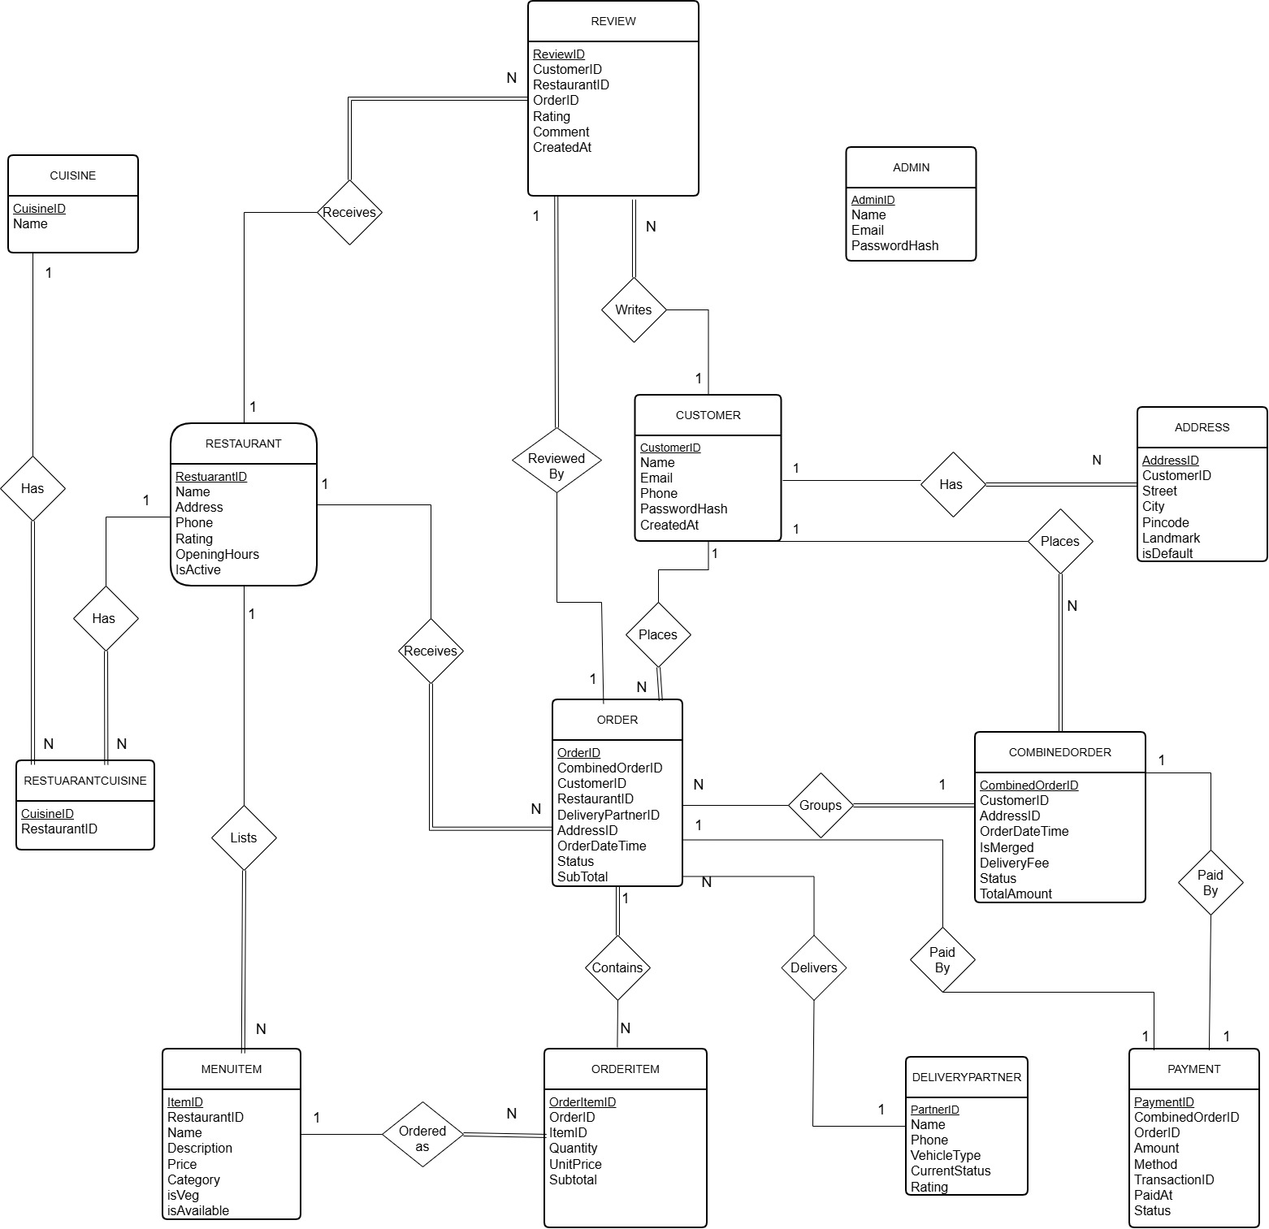

3.3 Relational Schema
Customer (CustomerID, Name, Email, Phone, PasswordHash, CreatedAt)

Address (AddressID, CustomerID, Street, City, PinCode, Landmark, IsDefault)

Restaurant (RestaurantID, Name, Address, Phone, Rating, OpeningHours, IsActive)

Cuisine (CuisineID, Name)

RestaurantCuisine (RestaurantID, CuisineID)

MenuItem (ItemID, RestaurantID, Name, Description, Price, Category, IsVeg, IsAvailable, ImageURL)

DeliveryPartner (PartnerID, Name, Phone, CurrentStatus, Rating)

CombinedOrder (CombinedOrderID, CustomerID, AddressID, OrderDateTime, IsMerged, DeliveryFee, OverallStatus, TotalAmount)

Order (OrderID, CombinedOrderID, CustomerID, RestaurantID, DeliveryPartnerID,
AddressID, OrderDateTime, Status, SubTotal, DeliveryFee, PaymentStatus)

OrderItem (OrderItemID, OrderID, ItemID, Quantity, UnitPrice, Subtotal)

Payment (PaymentID, CombinedOrderID, OrderID, Amount, Method, TransactionID, PaidAt, Status)

Review (ReviewID, CustomerID, RestaurantID, OrderID, Rating, Comment, CreatedAt)
Admin (AdminID, Name, Email, PasswordHash)

3.4 Normalization and Functional dependency analysis
Functional Dependencies
1. Customer
• CustomerID → Name, Email, Phone, PasswordHash, CreatedAt
• Email → CustomerID

2. Address
• AddressID → CustomerID, Street, City, PinCode, Landmark, IsDefault

3. Restaurant
• RestaurantID → Name, Address, Phone, Rating, OpeningHours, IsActive

4. Cuisine
• CuisineID → Name

5. RestaurantCuisine
• (RestaurantID, CuisineID) → ∅ (no non-key attributes)

6. MenuItem
• ItemID → RestaurantID, Name, Description, Price, Category, IsVeg, IsAvailable, ImageURL

7. DeliveryPartner
• PartnerID → Name, Phone, CurrentStatus, Rating

8. CombinedOrder
• CombinedOrderID → CustomerID, AddressID, OrderDateTime, IsMerged, DeliveryFee, OverallStatus, TotalAmount

9. Order
• OrderID → CombinedOrderID, CustomerID, RestaurantID, DeliveryPartnerID, AddressID, OrderDateTime, Status, SubTotal, DeliveryFee, PaymentStatus

10. OrderItem
• OrderItemID → OrderID, ItemID, Quantity, UnitPrice, Subtotal
• (OrderID, ItemID) → Quantity, UnitPrice, Subtotal

11. Payment
• PaymentID → CombinedOrderID, OrderID, Amount, Method, TransactionID, PaidAt, Status

12. Review
• ReviewID → CustomerID, RestaurantID, OrderID, Rating, Comment, CreatedAt

13. Admin
• AdminID → Name, Email, PasswordHash
• Email → AdminID
Candidate-key justification (attribute closure)
- Customer: {CustomerID}, {Email}
- Restaurant: {RestaurantID}
- CombinedOrder: {CombinedOrderID}
- Order: {OrderID}
- OrderItem: {OrderItemID} or {OrderID, ItemID}
- RestaurantCuisine: {RestaurantID, CuisineID}
Normalization Steps
- 1NF
All attributes are atomic. Multi-valued attributes (such as a list of cuisines for a restaurant or multiple addresses for a customer) have been eliminated by creating separate relations.
- 2NF
No partial dependencies exist on composite keys. In particular, OrderItem’s non-key attributes fully depend on the whole key {OrderID, ItemID}.
- 3NF
Transitive dependencies have been removed.
  - A customer may have multiple delivery addresses. Keeping Street, City, PinCode, Landmark inside the Customer relation would cause redundancy and update anomalies. Therefore, Address is extracted as a separate relation with AddressID as primary key and CustomerID as foreign key. This removes the transitive dependency and places the design in 3NF.
  - Cuisine names are similarly isolated in their own relation and linked through the RestaurantCuisine junction table.
- BCNF
Every determinant is a candidate key. The final set of relations satisfies Boyce-Codd Normal Form. Higher normal forms are not required.

